**Week of May 29- June 03**

This report covers all the tweets sent between May 27 – June 03 that mentioned “NickForVA”.

##### How many are retweets?  
   
 table(VA.tweetdf$isRetweet)

##   
## FALSE TRUE   
## 759 3880

The conversation was dominated by retweets, accounting for 3880 out of 4639, or 83.6%, of the total tweets.

**Top Tweets using “NickForVA”**

The following is an output of all the top 6 tweets with the most favorites and the most retweets in the tweets collection.

A screenshot of the tweets that have both highest favorites and retweets are below for visualization. In most cases, the same tweets made the list of top favorites and top retweets, so only visualization is provided.

**list of top 6 favorited retweet by NickForVA**

## text  
## 1 Thank you for your support! Let’s continue to put the pressure on Tim Kaine and win in November - vote June 12th an… https://t.co/WZYJjzH41v  
## 2 One thing I’ve learned is this: In politics and combat, cowardice is contagious, but so is courage. If you're willi… https://t.co/URDPE7Xs84  
## 3 Beware of politicians whose only way to “solve problems” is by continually expanding their own power while simultan… https://t.co/eCCtq1rbpx  
## 4 Kyle is a very impressive young man and I’m grateful to have his support in this race. Keep up the great work,… https://t.co/ohhkiEmW64  
## 5 While in the U.S. Senate, Tim Kaine has pledged to raise taxes, support government funding of Planned Parenthood, a… https://t.co/Q8wjQtqN7c  
## 6 Alex, thank you for your support and for all you do to promote school safety and veteran employment throughout Amer… https://t.co/YqbcquNjoz  
## favoriteCount created screenName  
## 1 5197 2018-06-02 16:13:40 NickForVA  
## 2 786 2018-05-29 15:48:32 NickForVA  
## 3 682 2018-05-31 03:37:59 NickForVA  
## 4 594 2018-05-31 18:34:44 NickForVA  
## 5 496 2018-06-02 22:57:41 NickForVA  
## 6 414 2018-06-03 15:56:13 NickForVA

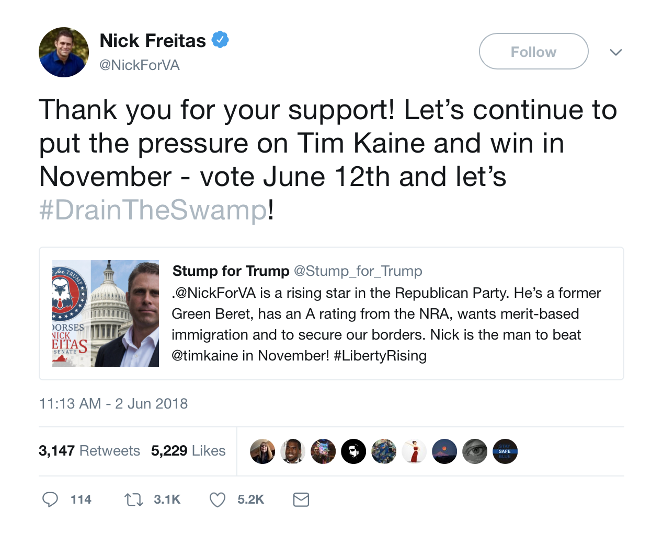



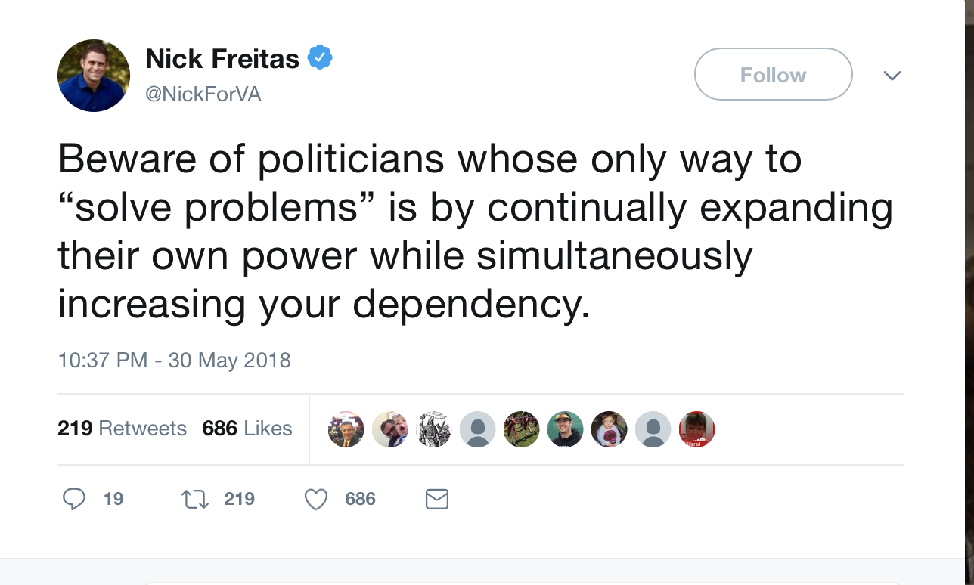

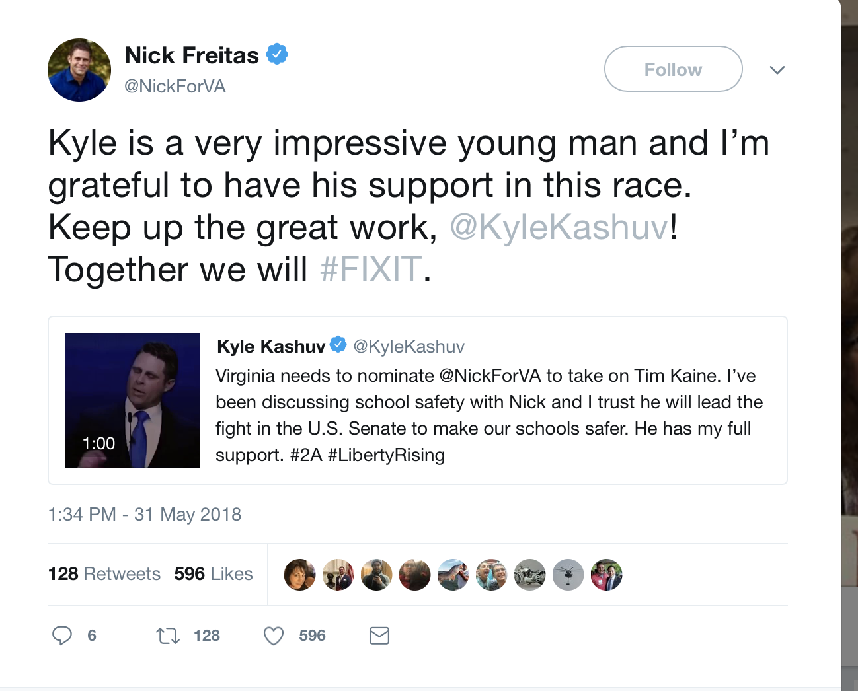

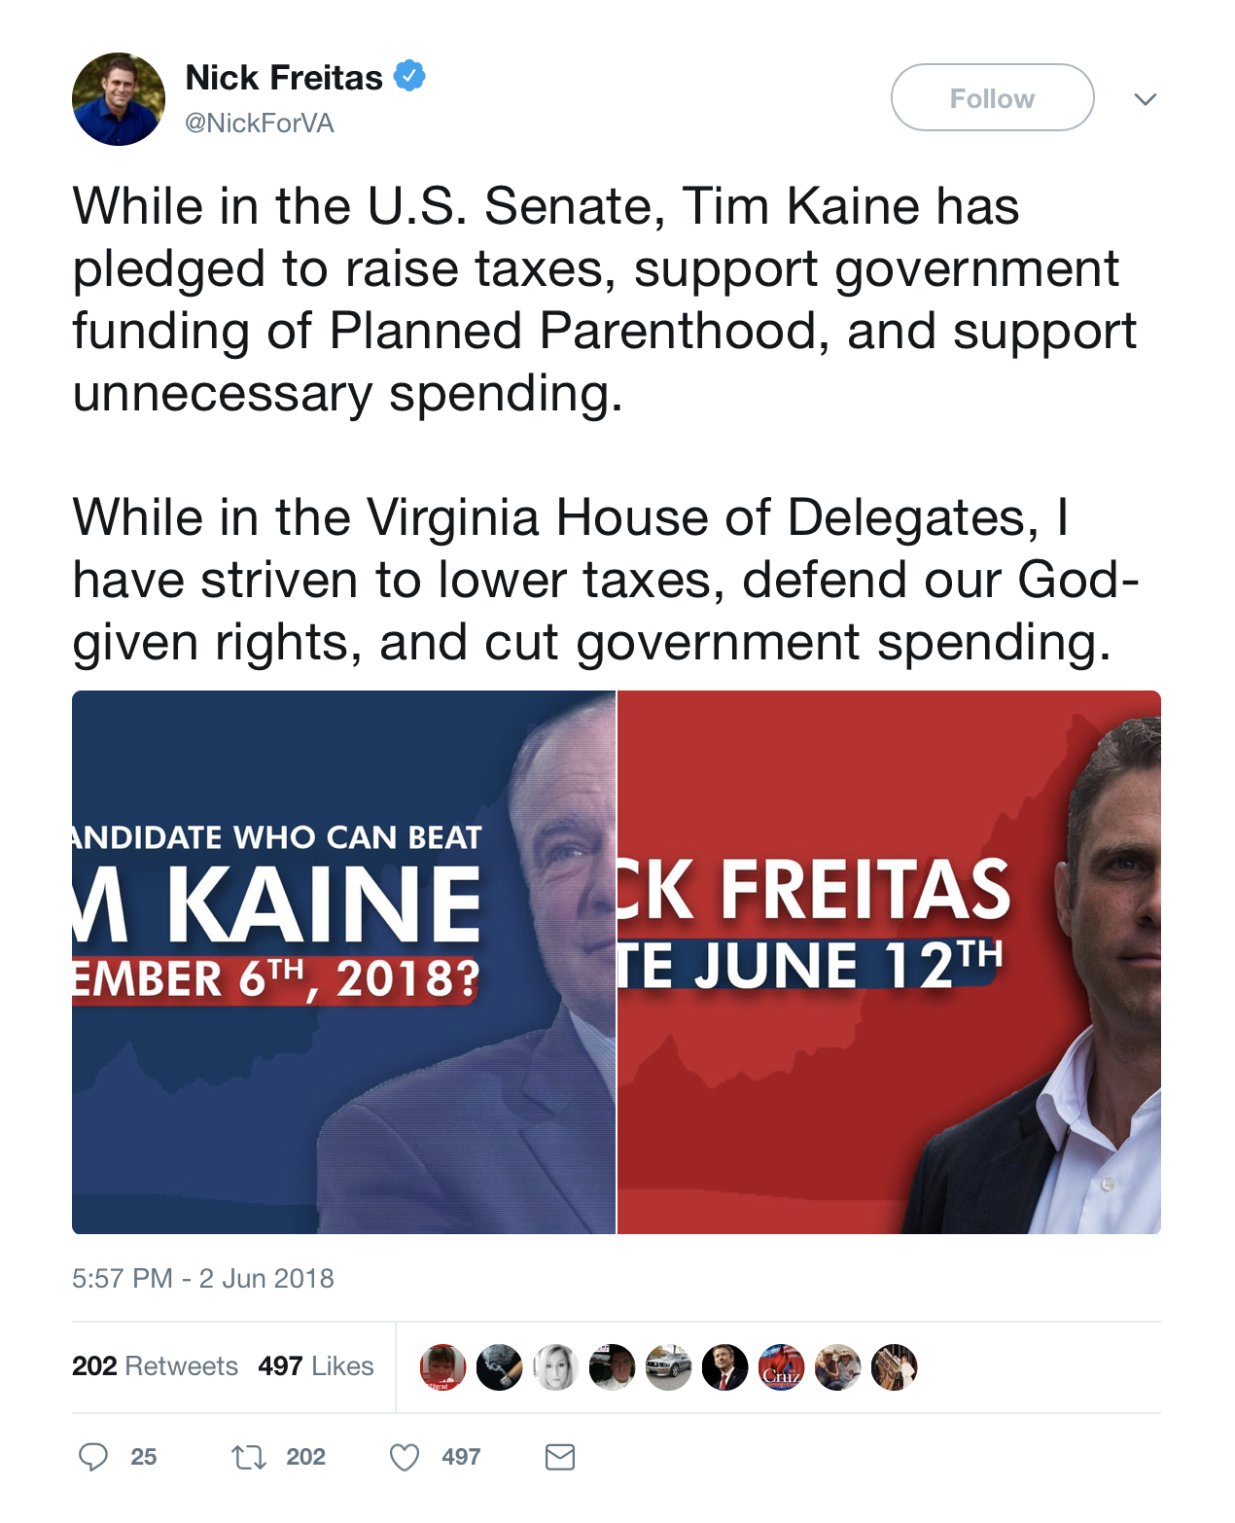

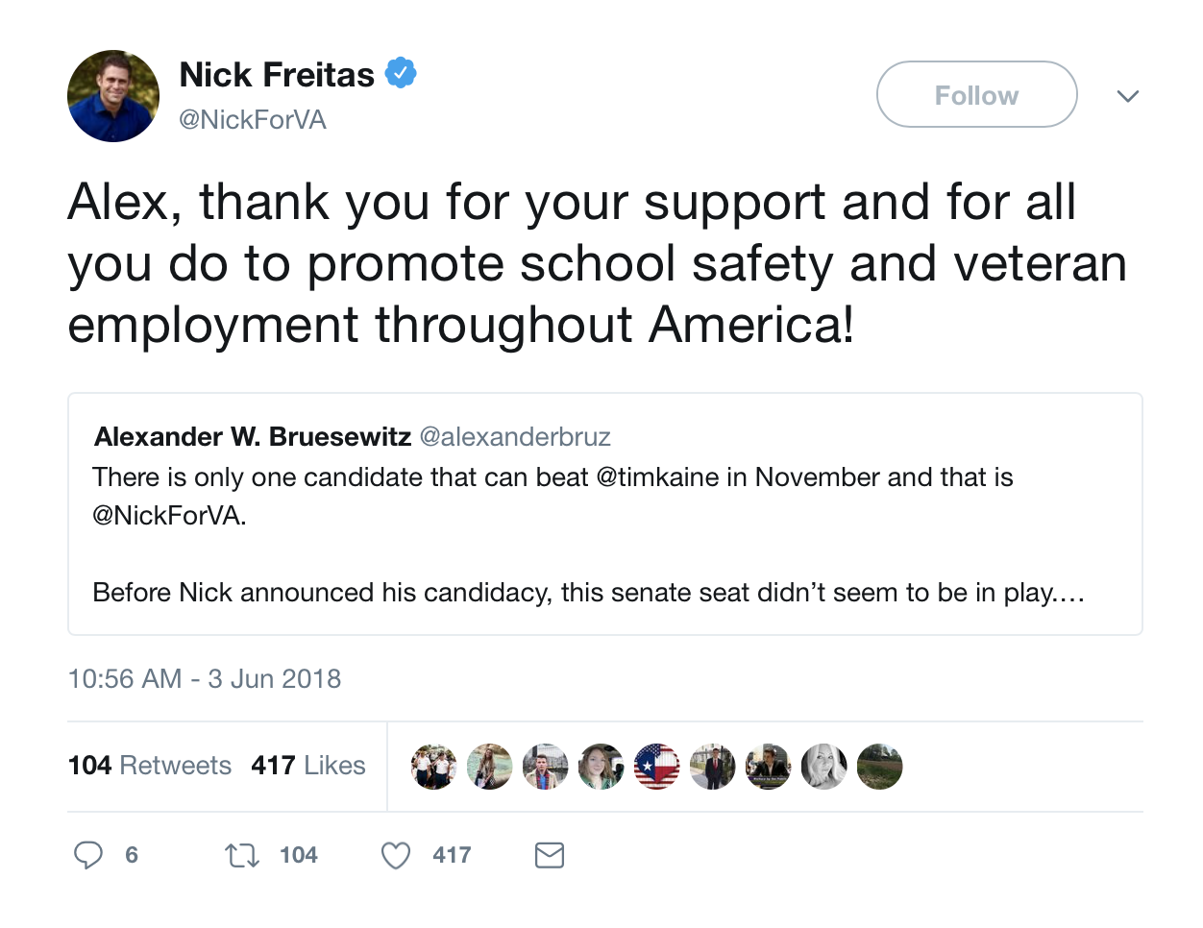

**other than from NickForVA account, most favorited**

## text  
## 1 .@NickForVA is a rising star in the Republican Party. He’s a former Green Beret, has an A rating from the NRA, want… https://t.co/TIkMlcExn3  
## 2 Virginia needs to nominate @NickForVA to take on Tim Kaine. I’ve been discussing school safety with Nick and I trus… https://t.co/Qzqix6PhIh  
## 3 There is only one candidate that can beat @timkaine in November and that is @NickForVA. \n\nBefore Nick announced his… https://t.co/mr1HKfB4z7  
## 4 Nick Freitas is a true patriot who will be a fighter for President Trump’s agenda in the U.S. Senate. He is the onl… https://t.co/NBrKGexAfL  
## 5 Why is @JohnCornyn protecting Tim Kaine (VA) by not putting National Reciprocity up for a vote during a Virginia Se… https://t.co/XEcZ4vbmW6  
## 6 If you’re looking for a candidate to get excited about, @NickForVA is the one.\n\nHe’s an experienced, principled lea… https://t.co/CgMu5kah0z  
## favoriteCount created screenName  
## 1 2317 2018-06-02 15:30:35 Stump_for_Trump  
## 2 590 2018-05-31 18:29:07 KyleKashuv  
## 3 568 2018-06-03 15:47:44 alexanderbruz  
## 4 542 2018-05-29 17:03:21 RyanAFournier  
## 5 178 2018-06-01 15:25:52 THEnickstarling  
## 6 147 2018-06-03 00:00:47 cabot_phillips

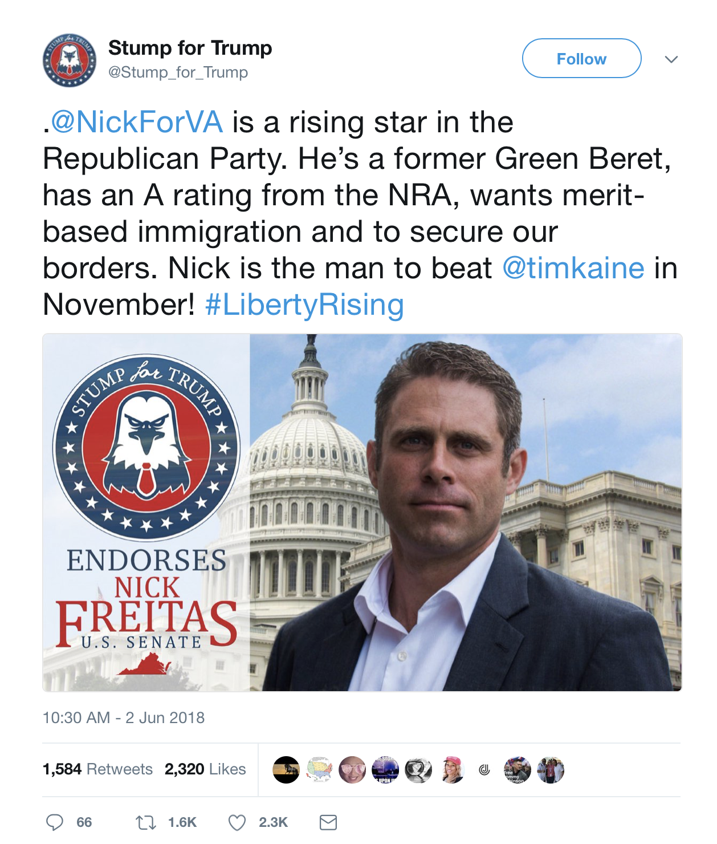

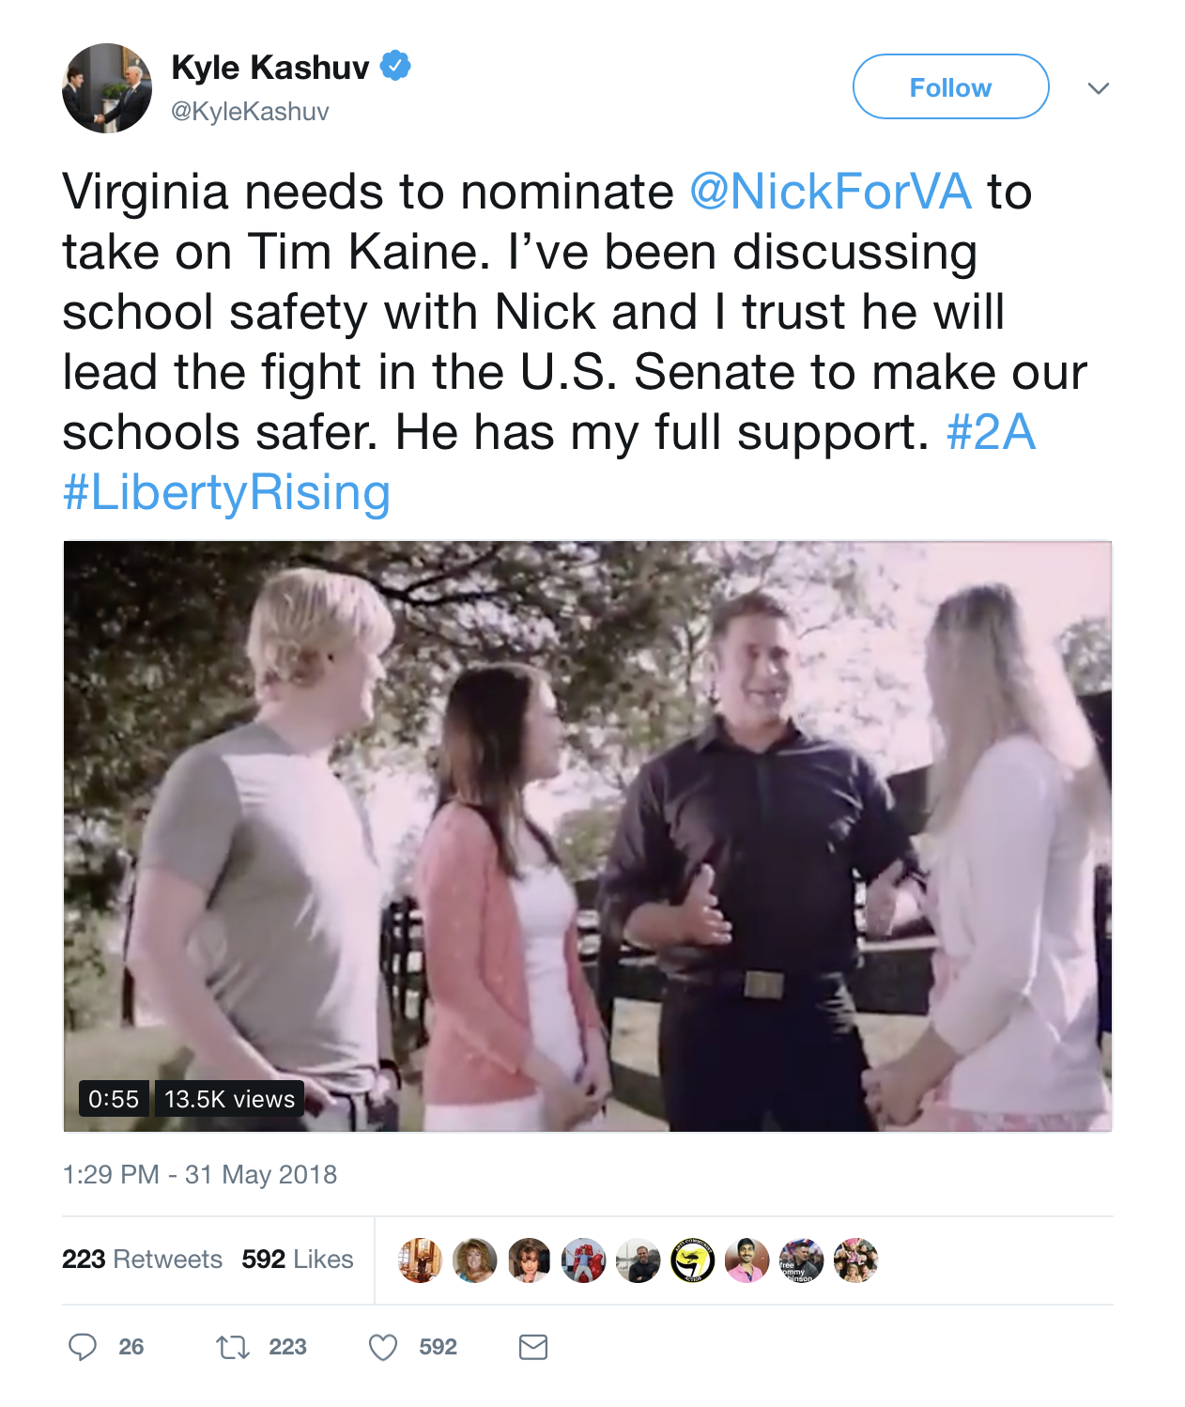

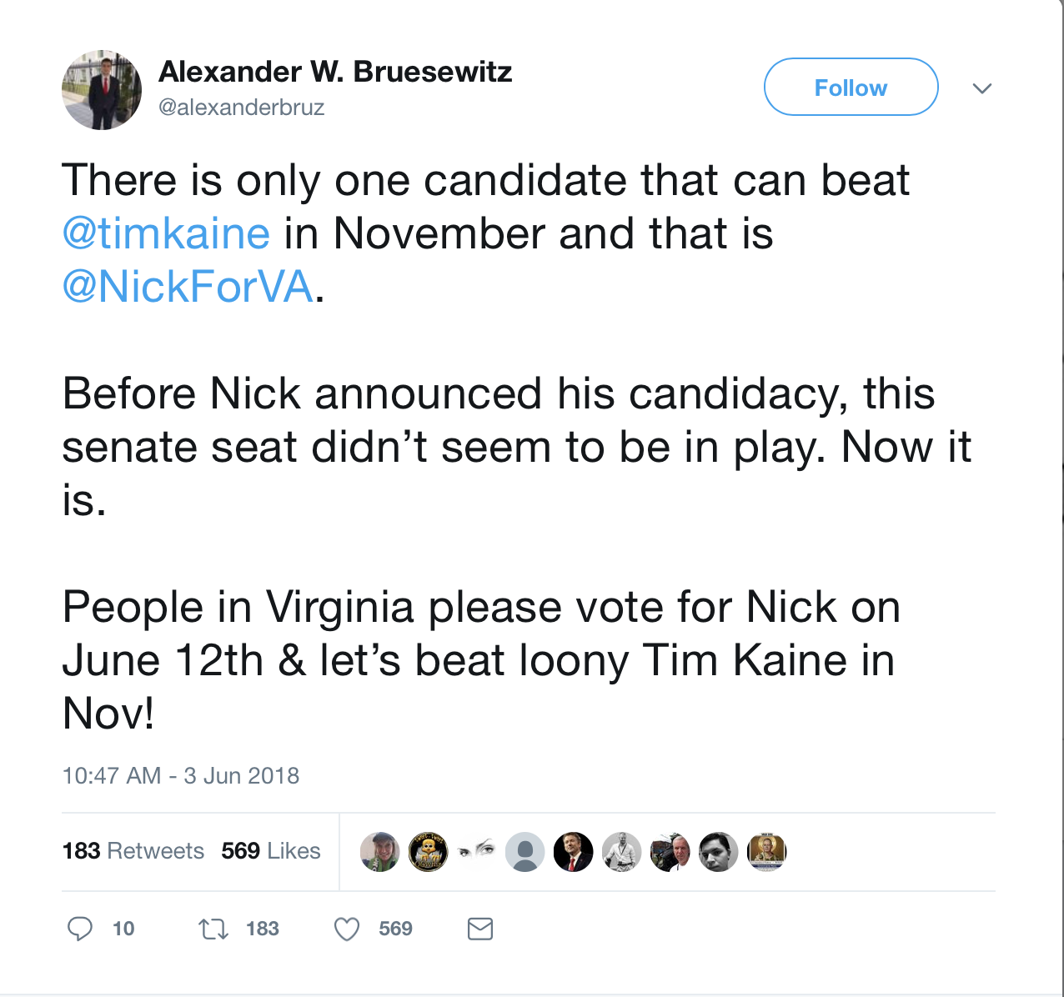

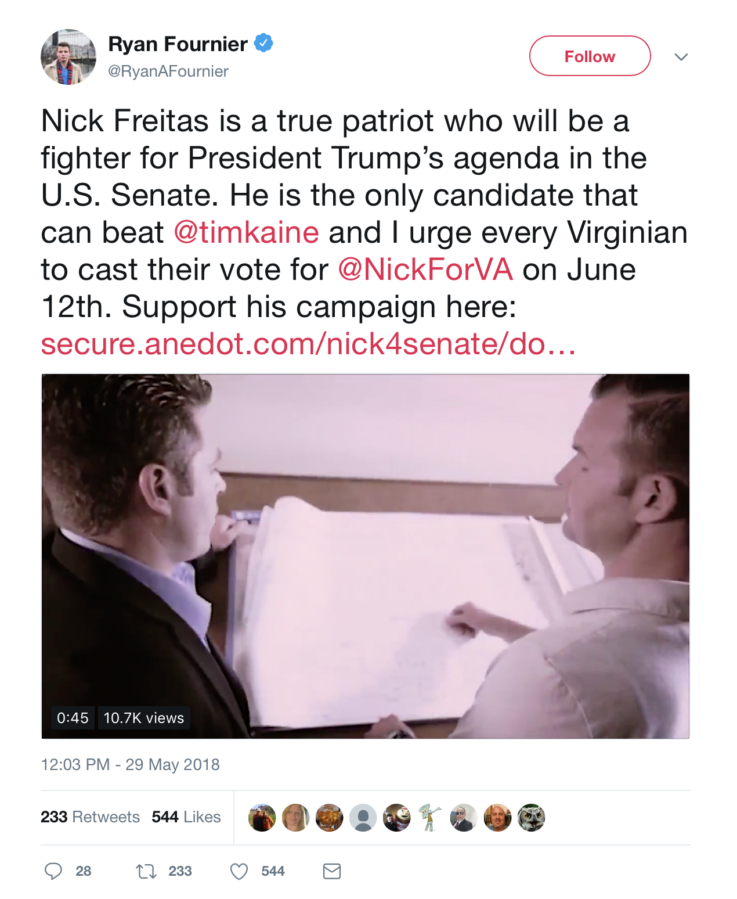

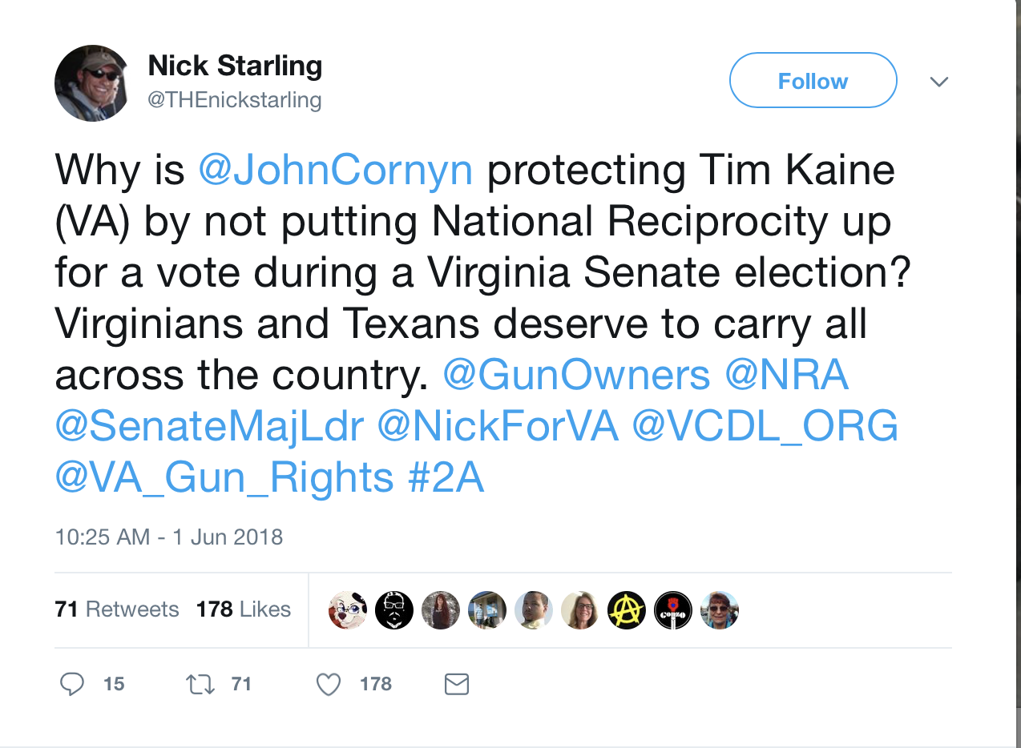

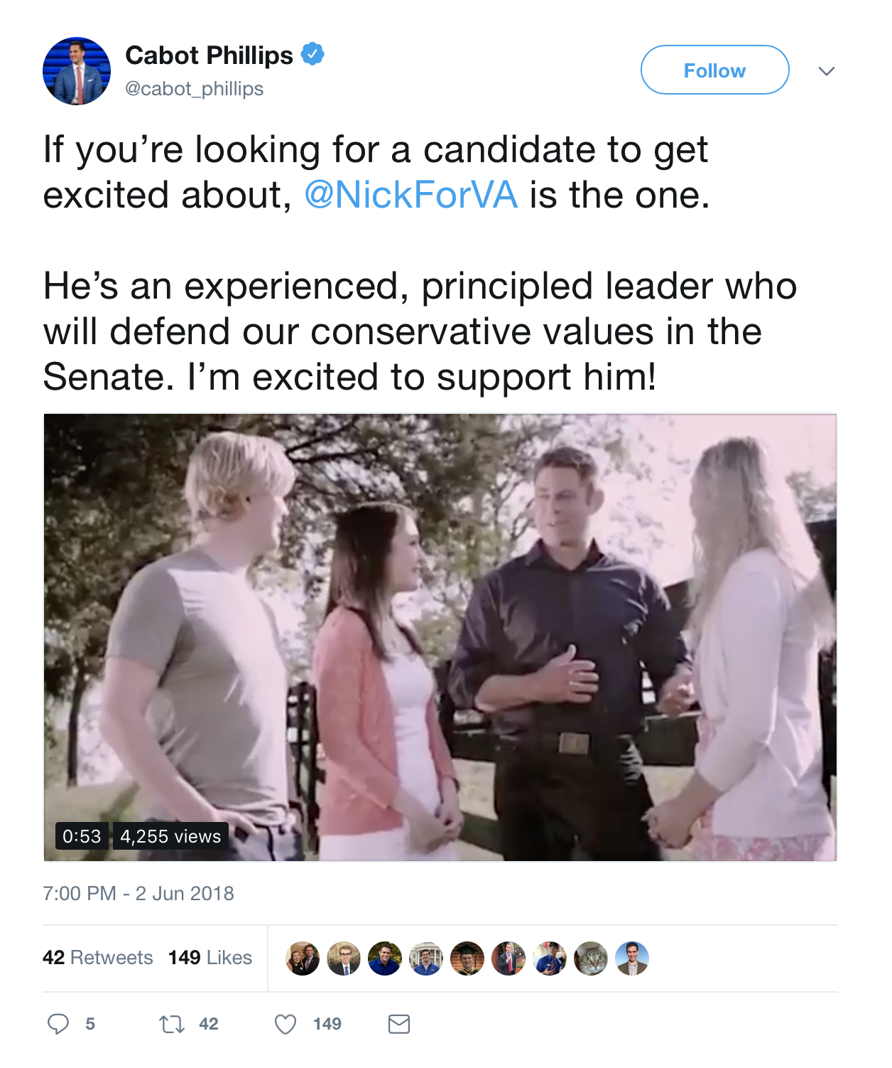

**top 6 retweeted tweet By NickForVA**

## text  
## 1 Thank you for your support! Let’s continue to put the pressure on Tim Kaine and win in November - vote June 12th an… https://t.co/WZYJjzH41v  
## 2 One thing I’ve learned is this: In politics and combat, cowardice is contagious, but so is courage. If you're willi… https://t.co/URDPE7Xs84  
## 3 RT @KyleKashuv: Virginia needs to nominate @NickForVA to take on Tim Kaine. I’ve been discussing school safety with Nick and I trust he wil…  
## 4 Beware of politicians whose only way to “solve problems” is by continually expanding their own power while simultan… https://t.co/eCCtq1rbpx  
## 5 While in the U.S. Senate, Tim Kaine has pledged to raise taxes, support government funding of Planned Parenthood, a… https://t.co/Q8wjQtqN7c  
## 6 Kyle is a very impressive young man and I’m grateful to have his support in this race. Keep up the great work,… https://t.co/ohhkiEmW64  
## retweetCount created screenName  
## 1 3133 2018-06-02 16:13:40 NickForVA  
## 2 372 2018-05-29 15:48:32 NickForVA  
## 3 222 2018-05-31 18:34:57 NickForVA  
## 4 221 2018-05-31 03:37:59 NickForVA  
## 5 201 2018-06-02 22:57:41 NickForVA  
## 6 127 2018-05-31 18:34:44 NickForVA

# top 6 retweeted tweet Not from NickForVA

## text  
## 1 .@NickForVA is a rising star in the Republican Party. He’s a former Green Beret, has an A rating from the NRA, want… https://t.co/TIkMlcExn3  
## 2 Nick Freitas is a true patriot who will be a fighter for President Trump’s agenda in the U.S. Senate. He is the onl… https://t.co/NBrKGexAfL  
## 3 Virginia needs to nominate @NickForVA to take on Tim Kaine. I’ve been discussing school safety with Nick and I trus… https://t.co/Qzqix6PhIh  
## 4 There is only one candidate that can beat @timkaine in November and that is @NickForVA. \n\nBefore Nick announced his… https://t.co/mr1HKfB4z7  
## 5 \xed\xa0\xbd\xed\xb4\xb4\u26aa️\xed\xa0\xbd\xed\xb4\xb5\xed\xa0\xbc\xed\xb7\xba\xed\xa0\xbc\xed\xb7\xb8\xed\xa0\xbd\xed\xb4\xb4\u26aa️\xed\xa0\xbd\xed\xb4\xb5\xed\xa0\xbc\xed\xb7\xba\xed\xa0\xbc\xed\xb7\xb8\xed\xa0\xbd\xed\xb4\xb4\u26aa️\xed\xa0\xbd\xed\xb4\xb5\n\n☑️ VIRGINIA \n\n☑️ PRIMARIES JUNE 12th\n @NickForVA\n☑️ VOTE NICK FREITAS\n\n☑️ FOR US SENATE… https://t.co/IlodsLDNmZ  
## 6 Why is @JohnCornyn protecting Tim Kaine (VA) by not putting National Reciprocity up for a vote during a Virginia Se… https://t.co/XEcZ4vbmW6  
## retweetCount created screenName  
## 1 1587 2018-06-02 15:30:35 Stump_for_Trump  
## 2 232 2018-05-29 17:03:21 RyanAFournier  
## 3 222 2018-05-31 18:29:07 KyleKashuv  
## 4 183 2018-06-03 15:47:44 alexanderbruz  
## 5 73 2018-06-01 21:04:42 HyltonRobin  
## 6 71 2018-06-01 15:25:52 THEnickstarling

### Top ten retweets overall

In this case, there were tweets that were created before the week that were still being shared on Twitter and accumulating retweets throughout the week.

Tweets number **1, 4, 5,** and **10** are the same tweets that were explored above, so their visualizations were omitted.

## text  
## 1 Thank you for your support! Let’s continue to put the pressure on Tim Kaine and win in November - vote June 12th an… https://t.co/WZYJjzH41v  
## 2 RT @charliekirk11: Nick is a total stud and Tim Kaine might be one of the most repulsive US Senators out there\n\nNick can win and unseat Tim…  
## 3 RT @NickForVA: I fought to protect my country as a Green Beret. \n\nAs Delegate, I fought against special interests to preserve our liberty a…  
## 4 RT @Stump_for_Trump: .@NickForVA is a rising star in the Republican Party. He’s a former Green Beret, has an A rating from the NRA, wants m…  
## 5 .@NickForVA is a rising star in the Republican Party. He’s a former Green Beret, has an A rating from the NRA, want… https://t.co/TIkMlcExn3  
## 6 RT @RodStryker: "The right to self defense &amp; the right to keep &amp; bear arms is one of many inalienable rights that government cannot grant n…  
## 7 RT @RandPaul: Today I stand with @NickForVA. He’ll make a tremendous addition to a stagnant US Senate. I ask you all to support him &amp; I ask…  
## 8 RT @Patriotic_Va: #NickFreitas dropping truth bombs \xed\xa0\xbd\xed\xb2\xa5\xed\xa0\xbd\xed\xb2\xa5 about our #2A rights! @NickForVA sounding pretty solid! \n\n#Virginians get out there…  
## 9 RT @NickForVA: We cannot accept another term of Tim Kaine &amp; his agenda.\n\nI've never stopped fighting for our conservative principles as a V…  
## 10 RT @NickForVA: One thing I’ve learned is this: In politics and combat, cowardice is contagious, but so is courage. If you're willing to be…  
## retweetCount created screenName isRetweet  
## 1 3133 2018-06-02 16:13:40 NickForVA FALSE  
## 2 3048 2018-05-31 15:17:19 MCEEEEEEEEE TRUE  
## 3 1688 2018-06-03 09:39:21 mackay_raymond TRUE  
## 4 1587 2018-06-03 23:51:43 planksk03 TRUE  
## 5 1587 2018-06-02 15:30:35 Stump_for_Trump FALSE  
## 6 871 2018-05-29 08:40:16 Lindanap123 TRUE  
## 7 831 2018-06-03 02:51:10 WontMarch4Soros TRUE  
## 8 770 2018-06-03 21:59:34 HUDAHAR2 TRUE  
## 9 500 2018-06-03 01:36:11 Len21878832 TRUE  
## 10 372 2018-06-03 23:25:22 VaBeachDi TRUE



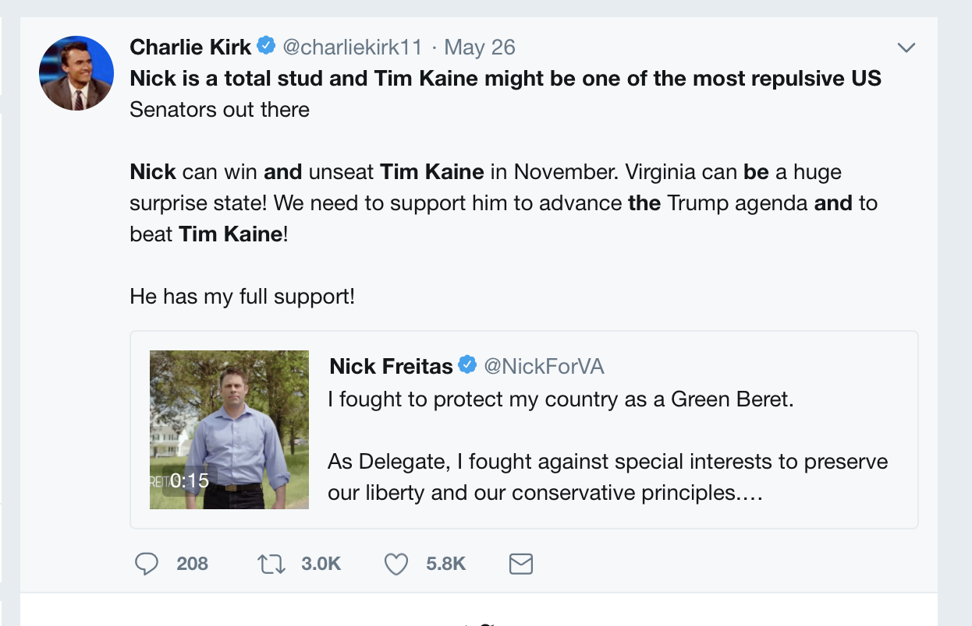

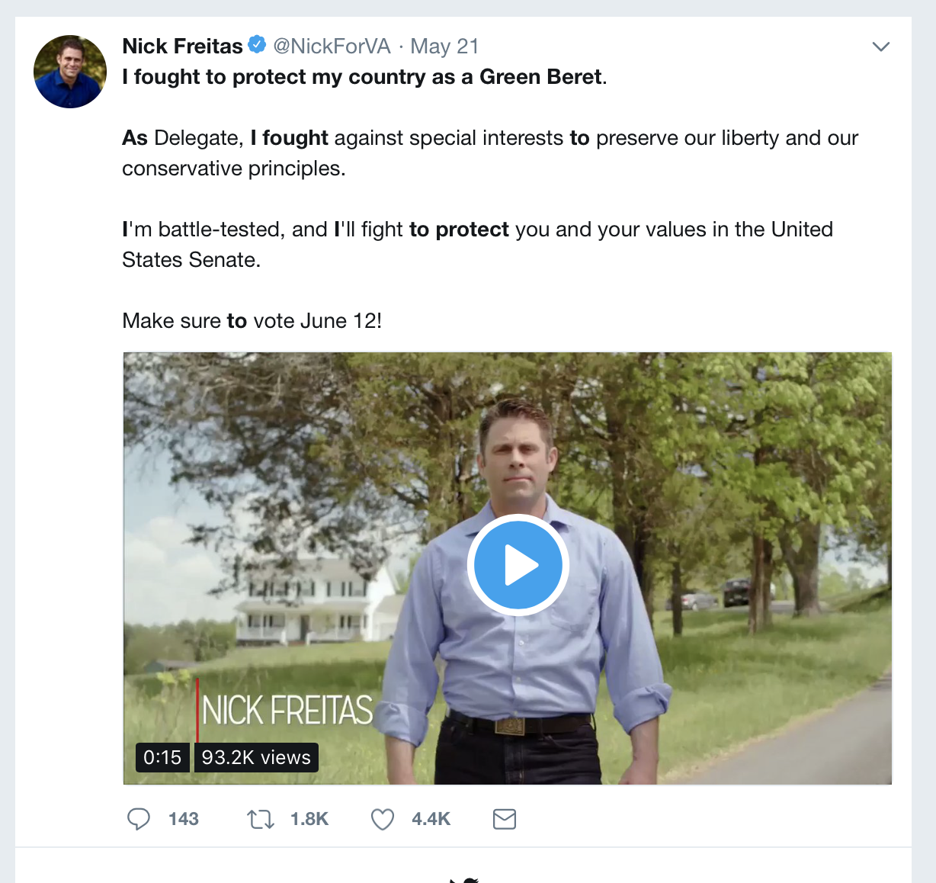

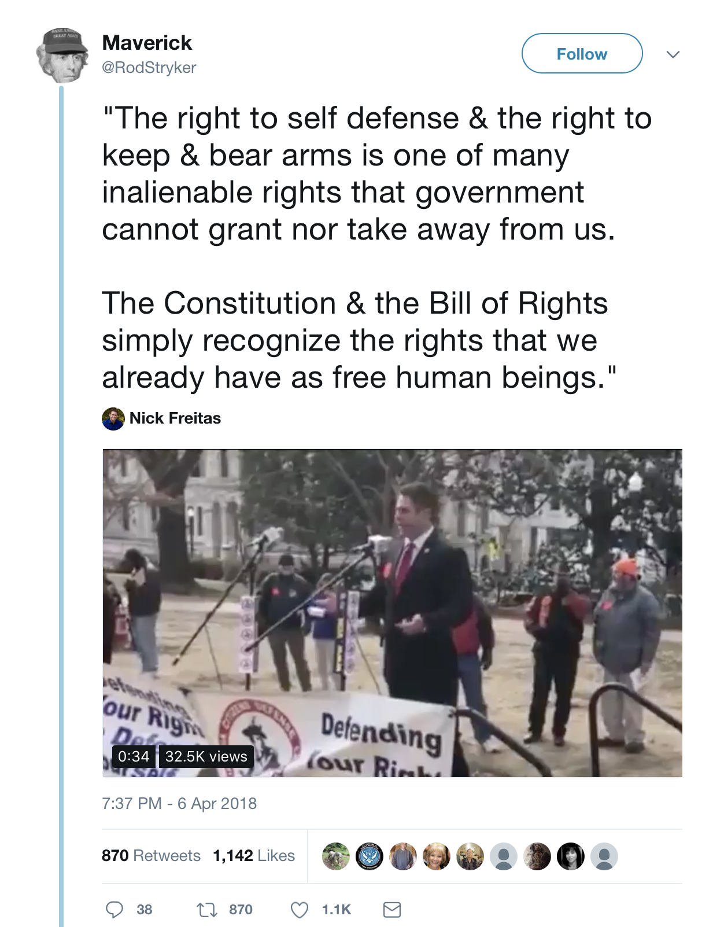

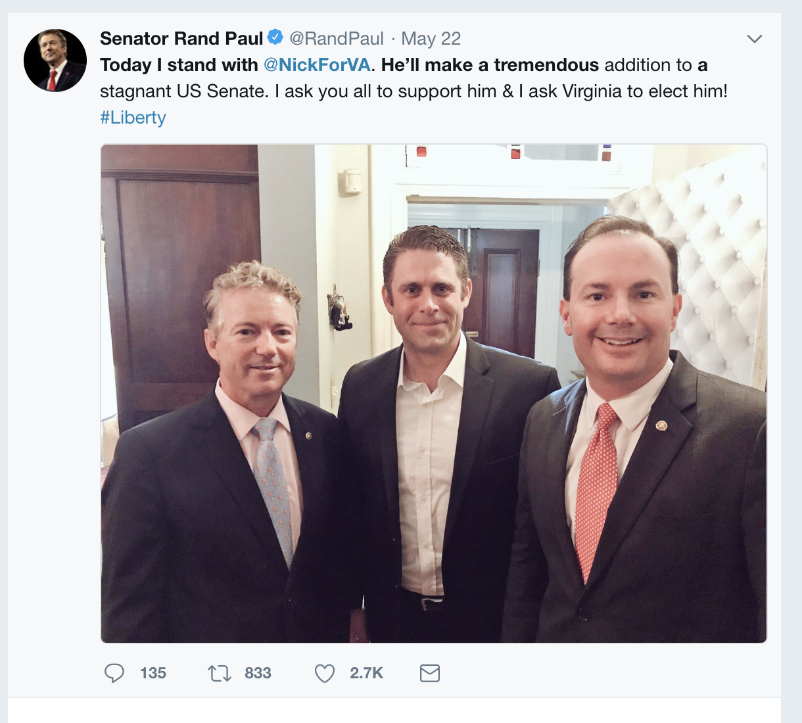

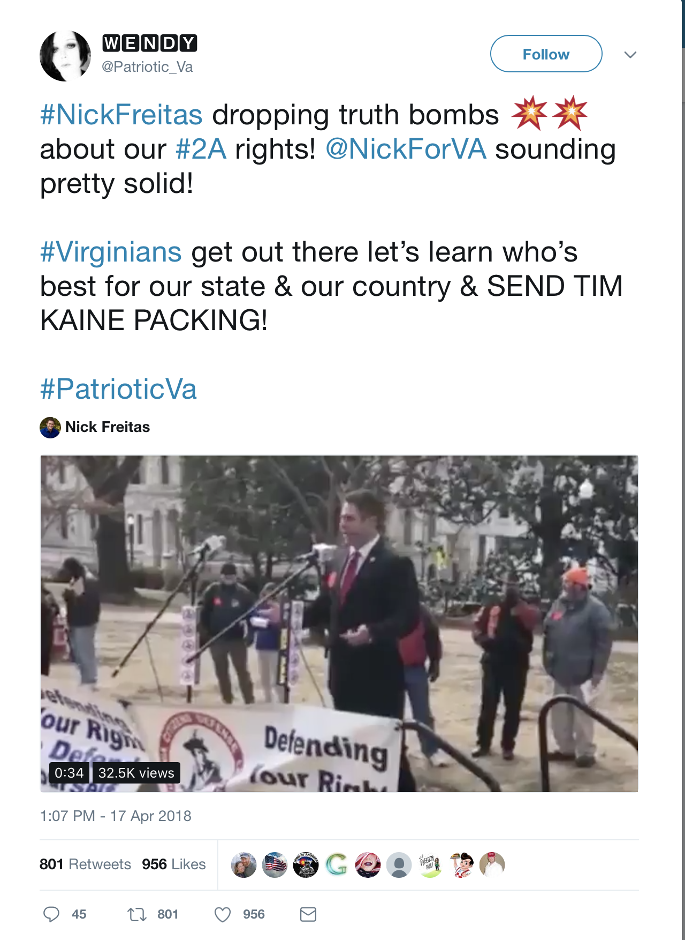

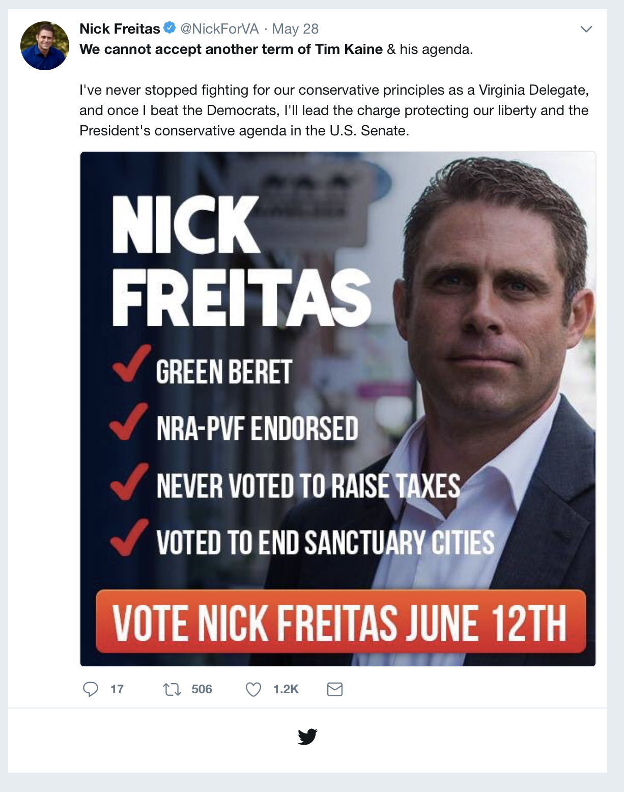

**Accounts dominating the Conversation**

These twitter handles have aggregated the most retweets out of all the tweets that they have sent out.

**accounts that have the most total Retweets**

## screenName Freq  
## 351 NickForVA 4693  
## 482 Stump_for_Trump 1587  
## 424 RyanAFournier 232  
## 263 KyleKashuv 222  
## 12 alexanderbruz 183  
## 117 DanWantsFreedom 82

**Most Active Accounts (including Retweets)**

These twitter handles have sent out the most tweets during the week (Including tweets)

## Var1 Freq  
## 1351 ItsChad 30  
## 2051 MFEUZ3 30  
## 2058 michael__1776 25  
## 2214 NickForVA 21  
## 1008 farmerfar55 19  
## 1668 KFordCB9 19

**Most Active Accounts**

These twitter handles have sent out the most original tweets during the week.

## Var1 Freq  
## 351 NickForVA 19  
## 209 ItsChad 17  
## 154 farmerfar55 12  
## 149 ehnottooxabi 9  
## 52 BNicholsLiberty 7  
## 127 DeborahDiltz 7

**VISUALIZATION**

# WORDCLOUD of most common used words

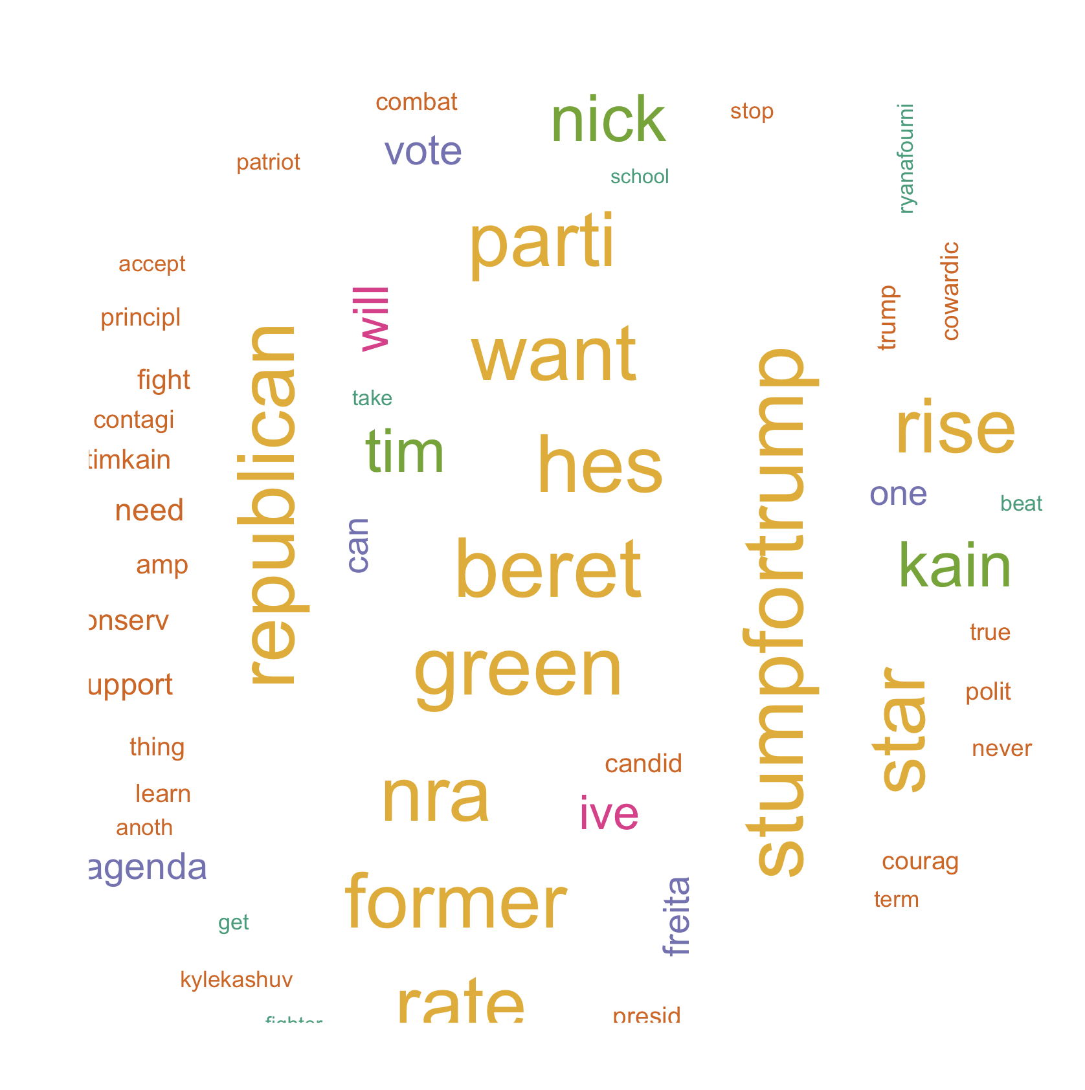

**List of The Top Ten Frequently used Words**

# ## word freq ## beret beret 1459 ## green green 1459 ## stumpfortrump stumpfortrump 1458 ## hes hes 1414 ## republican republican 1392 ## want want 1375 ## nra nra 1350 ## former former 1337 ## parti parti 1333 ## rise rise 1331

# Plot of Words that Appear at least 200 times

##   
## Attaching package: 'ggplot2'

## The following object is masked from 'package:NLP':  
##   
## annotate

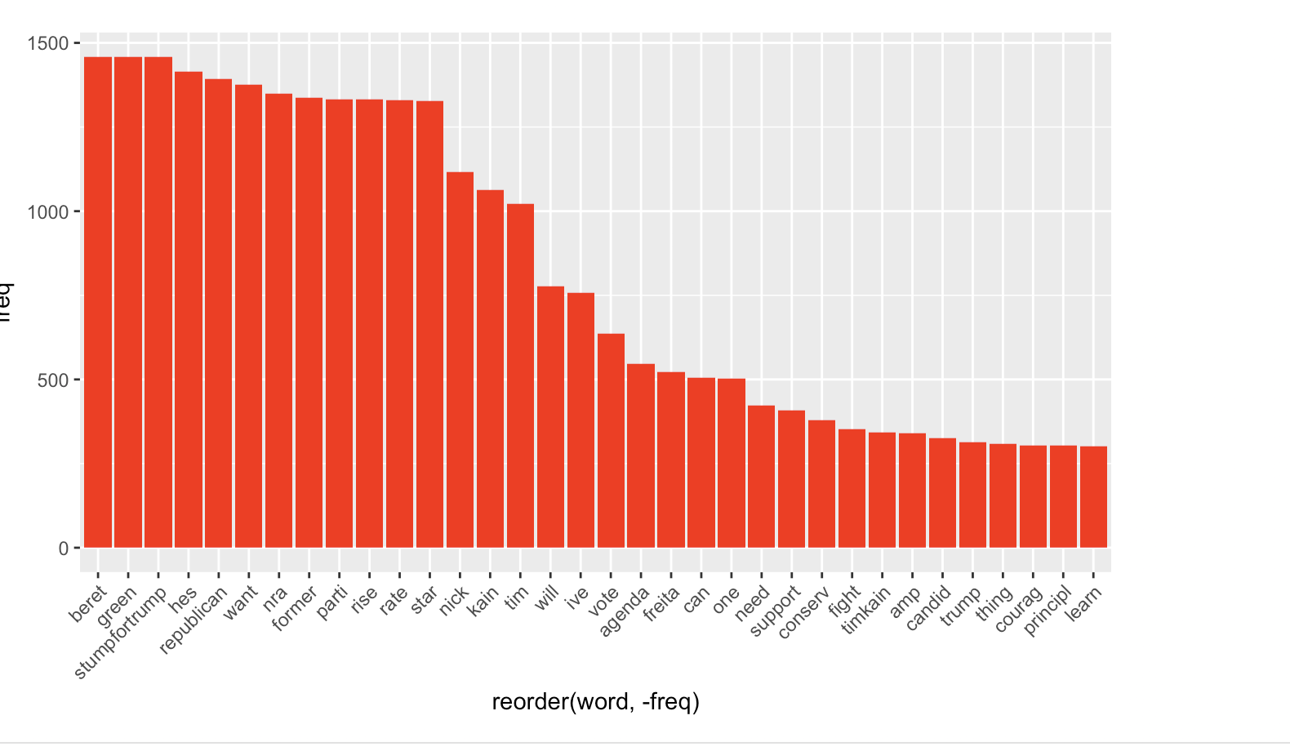

## Words Associated with

To find out what words are associated with the candidates, I use a function called FindAssocs() on the dataset. For any given word, findAssocs() calculates its correlation with every other word in the dataset. Scores range from 0 to 1. A score of 1 means that two words always appear together, while a score of 0 means that they never appear together.

# which words are associated with "Corey Stewart"  
   
 findAssocs(tdm,"coreystewartva", 0.1)

## $coreystewartva  
## fact craigcarp analysi correct   
## 0.57 0.53 0.50 0.50   
## matter wcve mult claim   
## 0.50 0.50 0.46 0.44   
## repeal weve full dependen   
## 0.42 0.42 0.38 0.38   
## iansam medicaid multipl princ   
## 0.38 0.35 0.33 0.33   
## william show stewart pawn   
## 0.33 0.30 0.28 0.27   
## rnc uhno virginiamagakag addit   
## 0.27 0.27 0.27 0.27   
## checker our expans icymi   
## 0.27 0.25 0.25 0.23   
## did creat bought exactl   
## 0.23 0.23 0.22 0.19   
## exa alwaysright proof burn   
## 0.19 0.19 0.19 0.19   
## crash prick swampmonst gilesgop   
## 0.19 0.19 0.19 0.19   
## incorrect smdinner johnrlinton barbaracomstock   
## 0.19 0.19 0.19 0.19   
## ewjacksonsr loudouninspir meemi repcomstock   
## 0.19 0.19 0.19 0.19   
## shakhil disagre akulakorah pal   
## 0.19 0.19 0.19 0.19   
## usin che rais they   
## 0.19 0.19 0.13 0.13   
## say tax big time   
## 0.12 0.12 0.11 0.11   
## corey worst larrysabato   
## 0.11 0.11 0.11

findAssocs(tdm,"nickforva", 0.1)

## $nickforva  
## stumpfortrump republican former nra parti   
## 0.28 0.26 0.26 0.26 0.26   
## rate rise star hes want   
## 0.26 0.26 0.26 0.24 0.23   
## ive beret green combat cowardic   
## 0.18 0.17 0.17 0.11 0.11   
## learn polit principl one courag   
## 0.11 0.11 0.11 0.10 0.10   
## thing   
## 0.10

findAssocs(tdm,"ewjacksonsr",0.1 )

## $ewjacksonsr  
## barbaracomstock loudouninspir meemi repcomstock   
## 1.00 1.00 1.00 1.00   
## shakhil coreystewartva   
## 1.00 0.19

# Number of Tweets per Day

##   
## Attaching package: 'scales'

## The following object is masked from 'package:readr':  
##   
## col_factor

